Pebble Shores Website – Getting Started
This is a brief GETTING STARTED tutorial for the official Pebble Shores website, for residents and guests.

Website location. With any computer internet browser or smart phone, navigate to the official website web address: www.pebbleshores.org 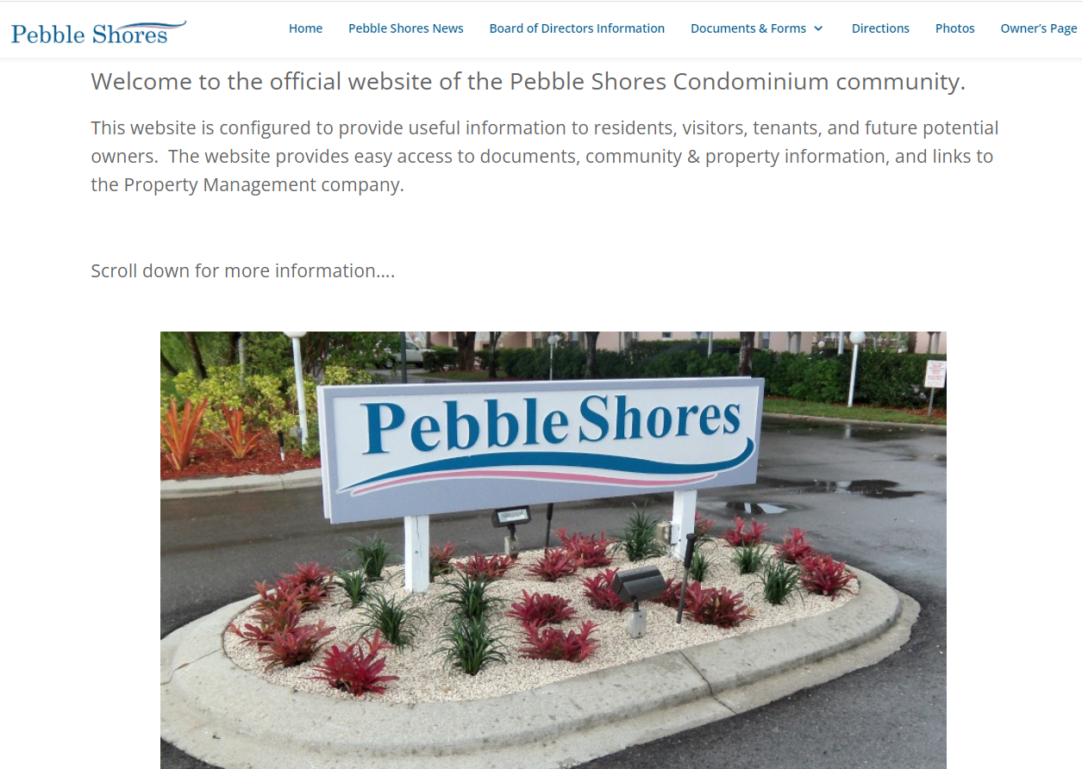
This is the home page, from where all other features of the website can be reached.

Navigating:
The website contains information tabs at the top of the page that are always available across the top of your browser page.
Submitting a Maintenance Request:
A link directly to the Gulf Coast website Maintenance Requests is posted half way down the home page for your convenience, along with an explanation of how to submit a Maintenance Request. THIS IS WHERE ANY PROPERTY PROBLEMS SHOULD BE REPORTED. 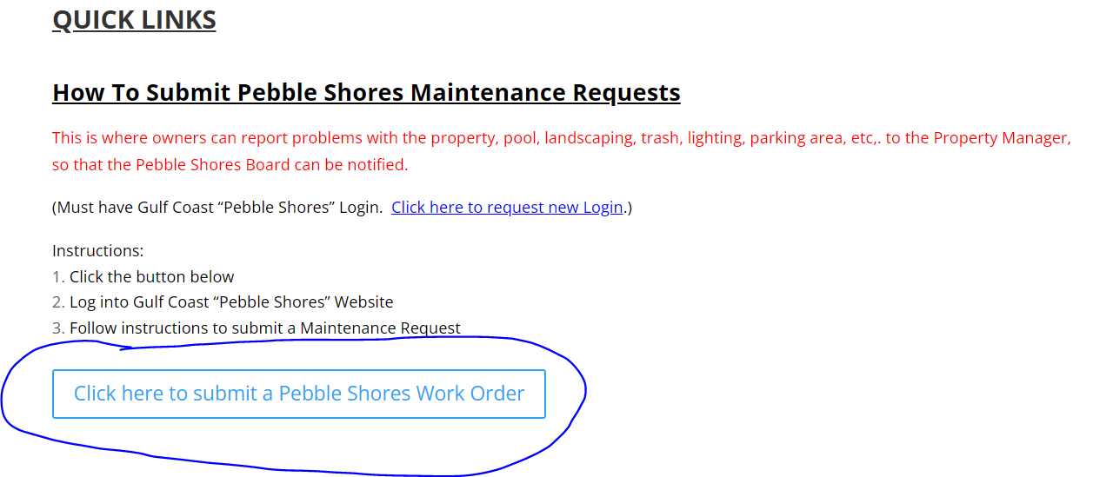
Simply click on the BLUE button, and you will be taken to the Login Page on the Gulf Coast Properties website, and once logging in, you will be taken to the Maintenance Request form. If you don’t have an account, a request link is at the bottom of the Login form:
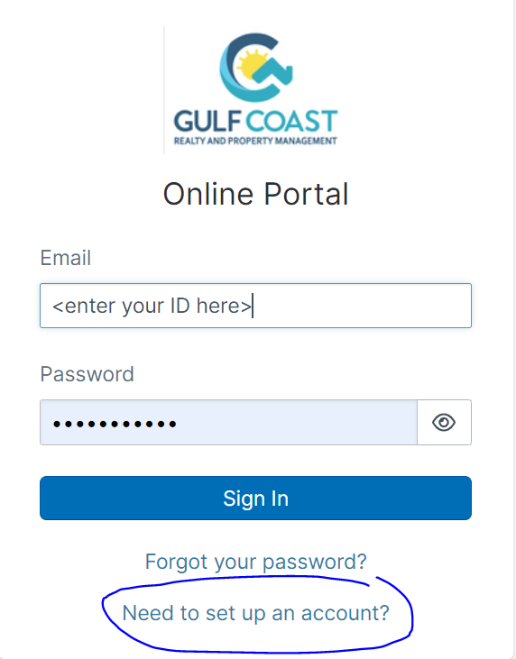

Facebook Page. There is a Pebble Shores private group that is active on Facebook. Further down on the website home page, is a link to this Facebook group, but understand that THIS IS NOT AN OFFICIAL PEBBLE SHORES WEB PAGE. THIS IS A FACEBOOK CHAT GROUP INTENDED FOR RESIDENTS AND GUESTS. This is not where to make property requests, maintenance requests, or to contact the Board or the Property Management company. This page is not actively monitored by the Pebble Shores Board or the Pebble Shores Property Management company.
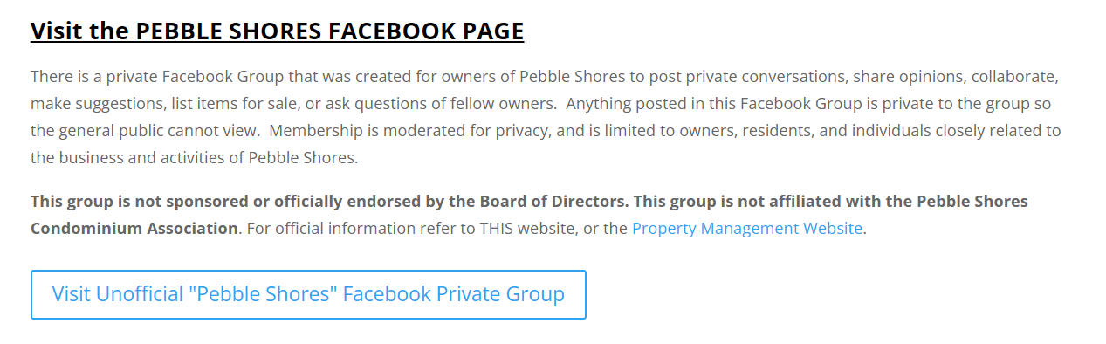
Clicking the link will take you to the Facebook group. You will need a Facebook account to access this group, but visiting the site gives you links for new accounts and for Facebook logins if you haven’t already done so.

Other Website Pages. All of the other pages behave similar to the Home page and the News page. Simply select the other links at the top of the page to navigate the rest of the website.

