Pebble Shores Website Tutorial
This is a brief tour of the official Pebble Shores website, for residents and guests.

- Website location. With any computer internet browser or smart phone, navigate to the official website web address: www.pebbleshores.org 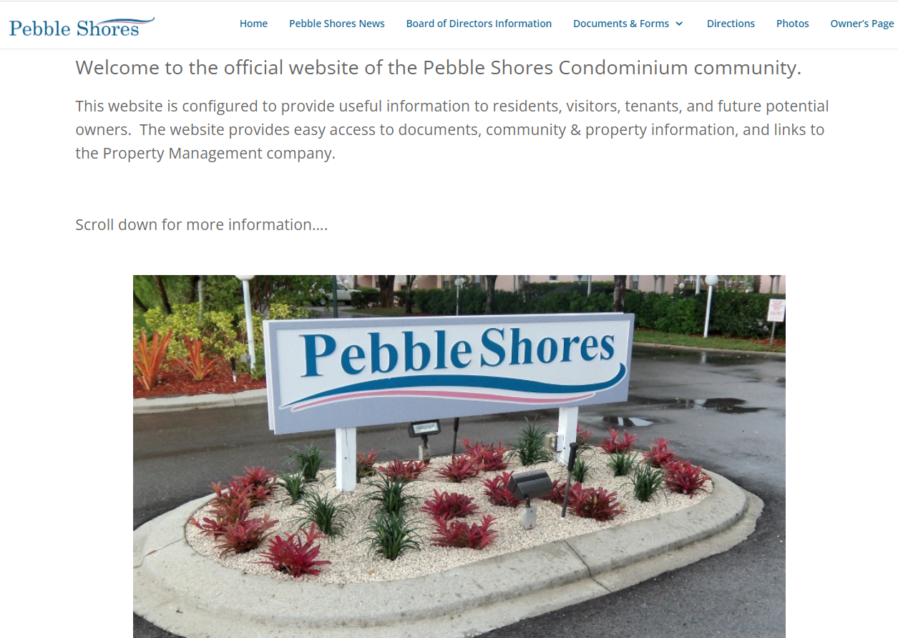This is the home page, from where all other features of the website can be reached.

  - The website contains information tabs at the top of the page that are always available across the top of your browser page.

  - Website Organization. The website information tabs are organized as follows:

- Home Page
  - Welcome message
  - Quick access links for first time visitors
- Pebble Shores News
  - Current news and events information
- Contact Information
  - Board Member information
  - Contact Information for Gulf Coast Property Management
- Documents & Forms
  - HOA Forms
  - Survey Results
  - Community Newsletters
- Directions
  - Link to Google-Maps for local directions
- Photos
  - Photo Gallery of the Pebble Shores property
- Owner’s Page (Login required)
  - Resident Login Form
  - New Account Request Form
  - Annual Budgets
  - Active Property Contracts & Contractors
  - Owner’s Directory
  - Renter’s Directory
  - Board Meeting Minutes
  - “Contact the Board” page

- Home Page. The home page is now a summary of the entire website. Many of the links on the top banner are also available on the home page. Also, several valuable quick links are posted here, for convenience.
  - Maintenance Request. A link directly to the Gulf Coast website Maintenance Requests is posted on the home page for your convenience, along with an explanation of how to submit a Maintenance Request. THIS IS WHERE ANY PROPERTY PROBLEMS SHOULD BE REPORTED. 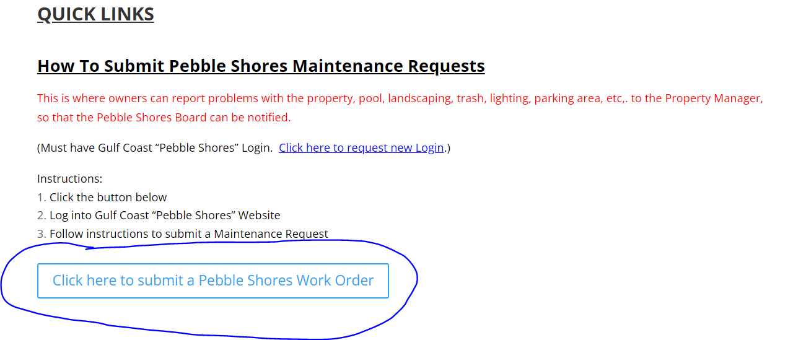 Simply click on the BLUE button, and you will be taken to the Login Page on the Gulf Coast Properties website, and once logging in, you will be taken to the Maintenance Request form. If you don’t have an account, a request link is at the bottom of the Login form:
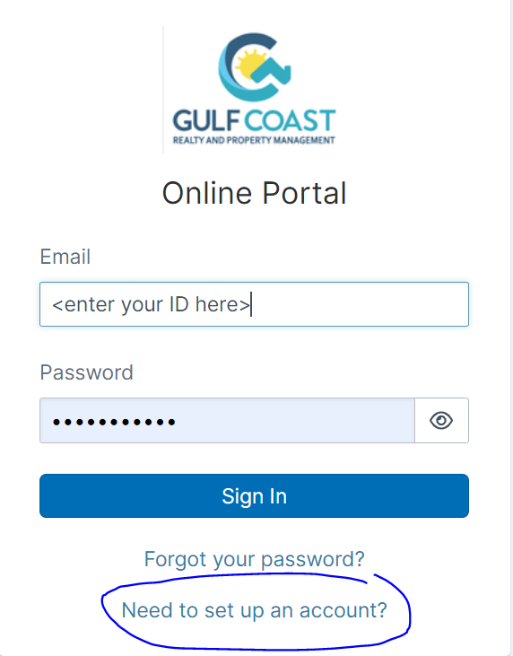

  - Gulf Coast website access. A link is provide that takes you directly to the Gulf Coast main website page. Just click on the BLUE button. 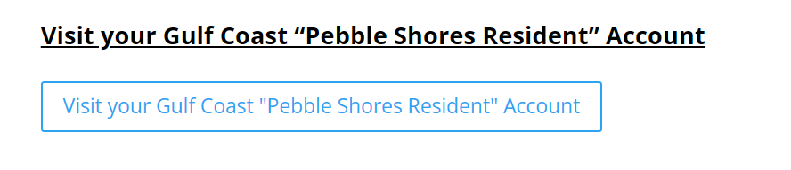 This link will take you to the Gulf Coast main page. If you have already logged into this page recently, then this link will take you directly to the Gulf Coast page. If not, then you will be taken to the Login screen. If you don’t have an account, then the link at the bottom of the form will give you an opportunity to request an account. ALL PEBBLE SHORES RESIDENTS ARE ENTITLED TO A GULF COAST PROPERTIES ACCOUNT. This is a worthwhile website as you can set up Association Fee payments, auto-pay for Association Fees, and access to all of the Pebble Shores property specific documentation.

  - Facebook Page. There is a Pebble Shores private group that is active on Facebook. The Pebble Shores Website front pages provides a link to this Facebook group, but understand that THIS IS NOT AN OFFICIAL PEBBLE SHORES WEB PAGE. THIS IS A FACEBOOK CHAT GROUP INTENDED FOR RESIDENTS AND GUESTS. This is not where to make property requests, maintenance requests, or to contact the Board or the Property Management company. 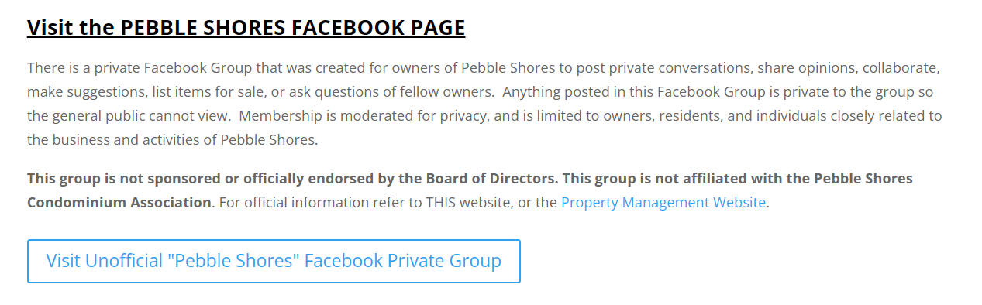Clicking the link will take you to the Facebook group. You will need a Facebook account to access this group, but visiting the site gives you links for new accounts and for Facebook logins if you haven’t already done so.

- Pebble Shores News page. The second page on the website is a Newsletter page. It is accessible by clicking the 2nd link across the top of the page. Click this link to see the latest news clips for the property, including the latest board meeting announcement, and the most recent property repair projects. 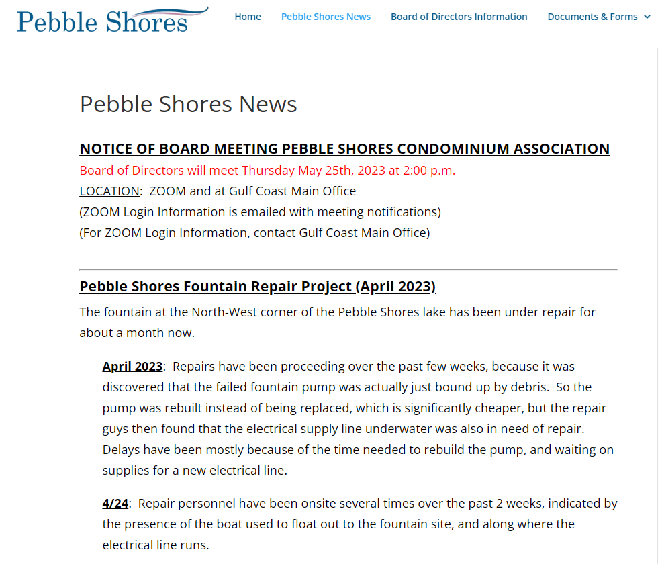 This page is manually updated as relevant new items are presented to the Board for general announcement. This is where Bingo nights and other Clubhouse get-togethers are announced, general contractor visits to the property, and any general news that is intended to be announced across the entire resident community.

- Board of Directors Information page. The 3rd tab takes you to an information page for the Pebble Shores Board. This is just general information though, as a more detailed information page for the Board, is contained behind the Owner’s Page which requires a login account. 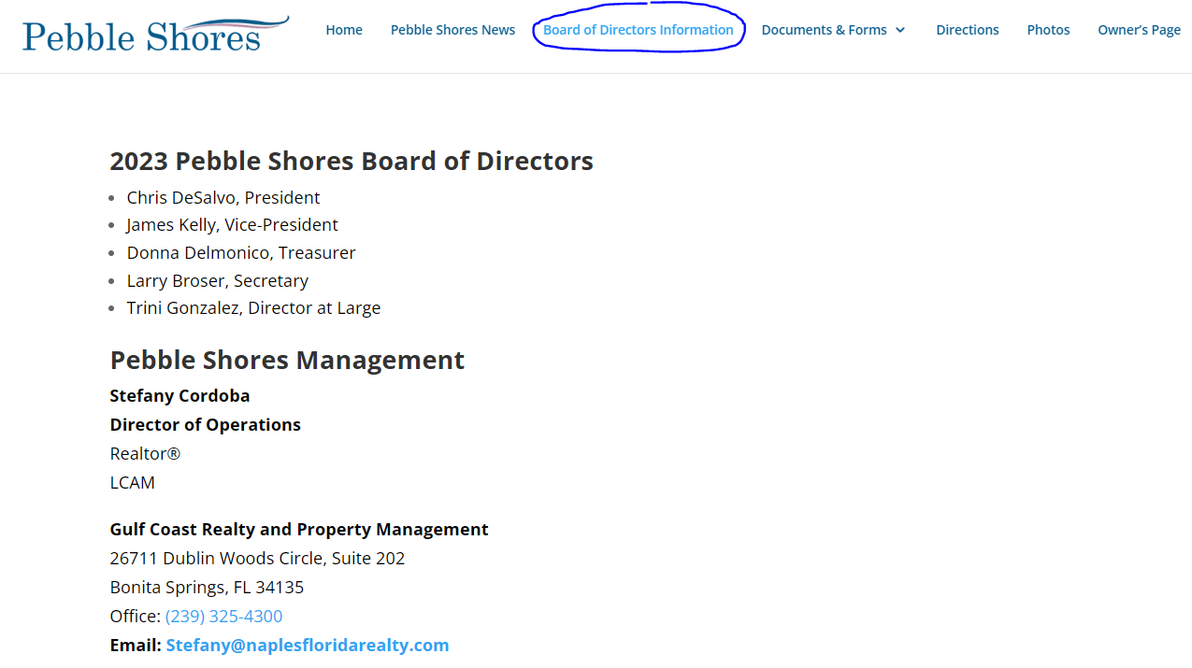 At the bottom of this page is a “Contact Us” form where you can contact the Website maintainers and the Board. 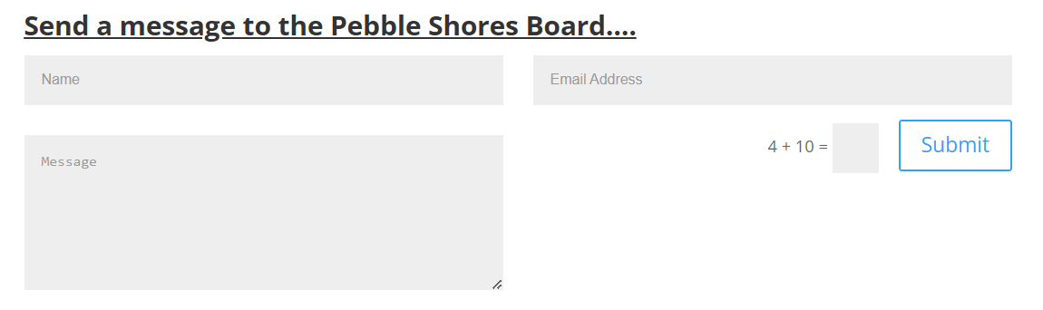 This communication form is how any resident can request an announcement on the News page, ask a website question, or for non-resident to contact the Board. However, this form is accessible to the public, so it often receives spam and unsolicited junk, so to reduce the junk, there is a little arithmetic problem that you have to complete before a message will be accepted. Be patient if sending any requests by this mailbox because it is manually checked.

- Documents & Forms page. The Documents and Forms page is intended to provide access to common forms that owners, visitors, renters, and prospective buyers may need.

- Directions page. The Directions page is simply a link to Google Maps, showing our location in the area. Most notable are HOA Forms, which are commonly needed for submitting landscaping modification requests, guest registrations, purchase approval applications, lease approval applications, parking permits, and clubhouse reservation requests.

This page is being updated with new forms from Gulf Coast Property Management, as some forms posted are still from the previous property manager.

- Photos page. The Photos page is simply a gallery of photos of the property. Many photos remain from when the website was initially set up back in 2016. Updated photos are posted periodically.

- Owner’s page. This is the page that only owners/residents can access, so there is a login that is required. Behind this login is the following information:

Much of this information is also available on the Gulf Coast Property Management website. Residents can access this information at either site, but the Gulf Coast site will always be more current, as it is a corporate site and there is a full-time team maintaining that website.

When you visit this page you will see a Resident Login form, and another form where a new User Account can be requested.
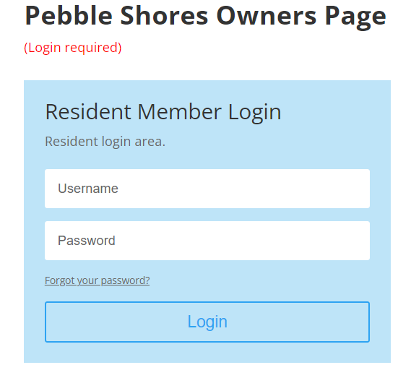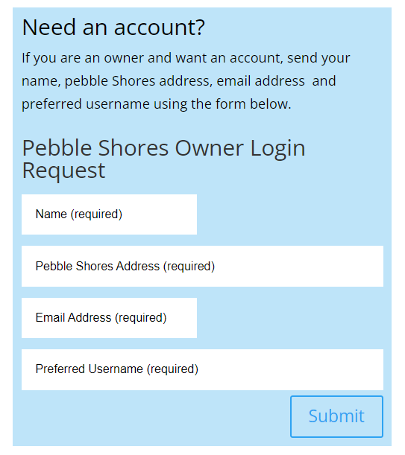
Be patient when requesting an account, because it is a manual process to verify residency, and this form is on a public facing webpage, so the website administrators sometimes receive junk requests.

Once logged into the Owner’s Page, a link will appear taking you to the Owner’s Page data.

- Owner’s Page details. Behind the Owner’s Page Login screens is where the private residents-only data is stored, so that it is not accessible to the general public. This area changes based on decisions by the Board and advice from the Property Manager. 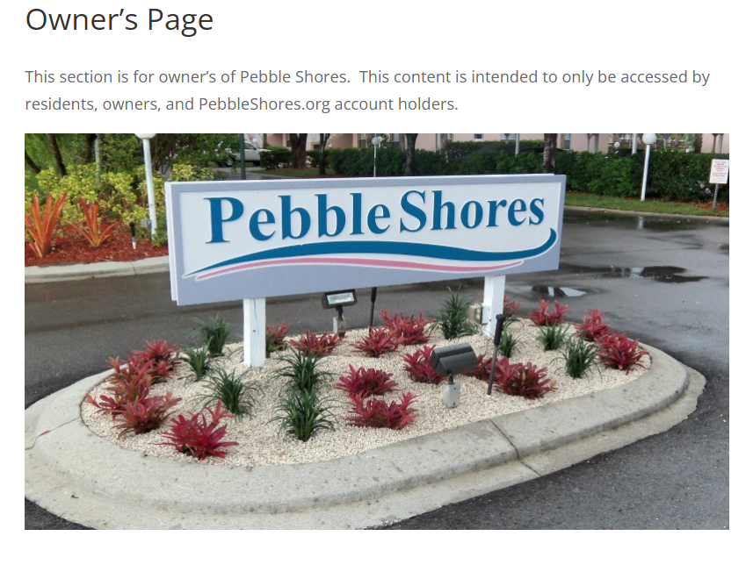
Simply click on the BLUE links on this page, to navigate the owner-only documentation.

Much of the data on this page is also saved on the Gulf Coast Property Management website. Documents stored on the Pebble Shores website are intended to be the persistent archive of this information. This came about from the previous property management companies storing documentation in different ways, so the Pebble Shores Website was intended to provide a consistent archive of this documentation for the long term.

